Lab Assignment 2
Stepan Shkrobak
Dr. Michael Bartolacci
IST 894, Section 001: Capstone Experience,
8 February 2026

1. General Context 1
2. Technical Context 2
3. Resources 4
4. Screenshots 4
Nmap and Hping 4
Applied Nmap 5
Basic Scripting 7
Lab Completion 8

General Context
Network reconnaissance is key to any attack or defense development. In these labs, various tools and methods are used to discover networks, enabling the identification of potential vulnerabilities that can then be used for further and deeper reconnaissance or even attack. Nmap is one of the tools that allows for identifying active hosts, determining open network ports, and identifying service and operating system information without actually exploiting them. This is similar to a property inspector walking through a building to note every door, window, and entry point before deciding where improvements are needed. Discovering hosts and software versions is one of the simplest ways to find vulnerabilities in known software versions that can be exploited.
In the applied Nmap lab, we perform an Nmap scan, which reveals an FTP service that is running with an outdated software version and weak configuration. Legitimate credentials are then used against the FTP service, granting us access, confirming the vulnerability, and authenticating and accessing the files. This workflow mirrors what penetration testers do in real engagements: find the weak door, check if the lock works, and then determine whether known flaws can be exploited. This access could allow an attacker to further exploit the vulnerability and move across the network laterally or load new data onto the FTP in addition to accessing and being able to take data off.
The labs finish off with custom scripting in Python and Bash. Scripting allows for automating repetitive tasks, for example, predefining all the commands we normally would run in the terminal into one script file, which, when run, executes all the commands one after the other at a faster rate than a human typing could do. These skills enable security professionals to build tailored tools for repetitive tasks or integrate multiple utilities into coherent workflows. This is great for organizations as they can develop complex scripts that they can run to perform a complete test of their network, and have it saved to repeat, for example, after they make patches to see if the vulnerability that was identified is no longer there, or now have the script to be able to run on a scheduled basis.

Technical Context
Network reconnaissance forms the technical baseline for both offensive security testing and defensive risk assessment because it provides measurable visibility into exposed network services and system characteristics. Using tools such as Nmap, we enumerate live hosts, identify listening TCP and UDP ports, and fingerprint services and operating systems through packet analysis and response behavior. These scans rely on techniques such as SYN probing, banner grabbing, and stack fingerprinting rather than exploitation, which allows us to map the attack surface without altering target systems. The resulting data set, including port states and detected software versions, can then be correlated with known vulnerability databases to identify systems that may be running unpatched or insecure services.
In the applied Nmap portion of the lab, reconnaissance advanced into service enumeration and exposure validation. Version detection identified an FTP daemon running an outdated release with insecure configuration indicators, suggesting susceptibility to known weaknesses or poor access control. After confirming the service was reachable, authenticated access using valid credentials demonstrated that the exposure translated into functional system access. This step verified that the risk was not theoretical but operational, since authenticated FTP access enables file retrieval, file upload, and potential staging of additional tools or payloads. In real network environments, this type of foothold can support privilege escalation attempts, data exfiltration, or lateral movement through credential reuse and trust relationships.
The scripting component of the lab reinforced the technical mechanics behind automation in security operations. Using Python socket programming, we programmatically established TCP connections and interpreted connection states to determine port accessibility, effectively recreating simplified scanning logic at the code level. In parallel, Bash scripting demonstrated how command execution, exit codes, and conditional logic can be combined to automate multi-step testing workflows. These techniques enable repeatable and scalable assessments, reduce manual execution errors, and support continuous validation by allowing the same scripted tests to be rerun after system updates or configuration changes. Results could be output to various file formats so that they can be ingested for complex analysis of all the outputs and results.

Resources
Nmap Project. (n.d.). Nmap: Network mapper. https://nmap.org/
Kumar, A. (2023). Exploiting FTP vulnerabilities for effective penetration testing. Medium. https://medium.com/%401200km/exploiting-ftp-vulnerabilities-for-effective-penetration-testing-a2810df78602
SecurityScorecard. (n.d.). FTP security risks organizations should know about. https://securityscorecard.com/blog/ftp-security-risks
OWASP Foundation. (n.d.). OWASP: Open Web Application Security Project. https://owasp.org/

Screenshots

Nmap and Hping
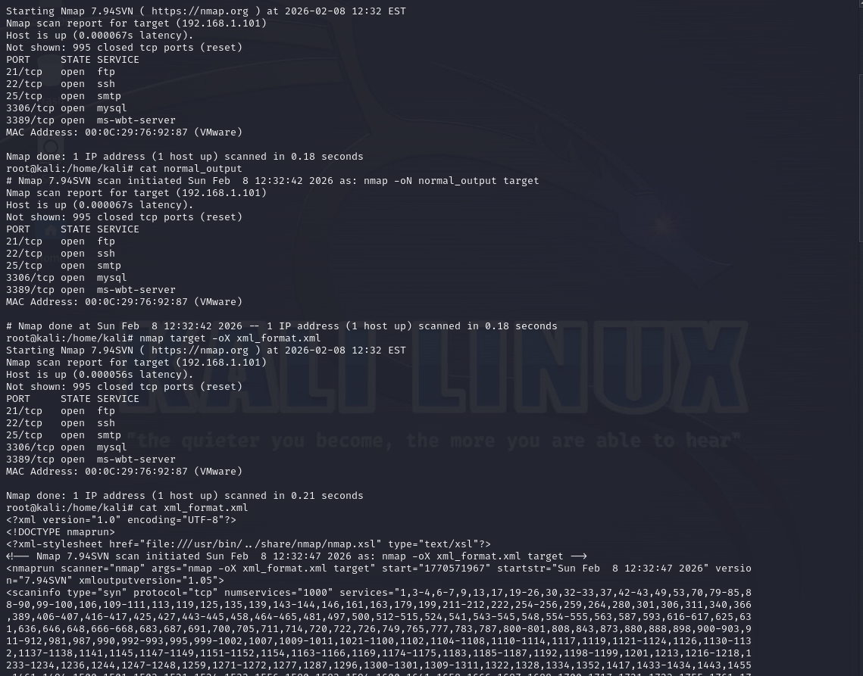
Service Version Detection
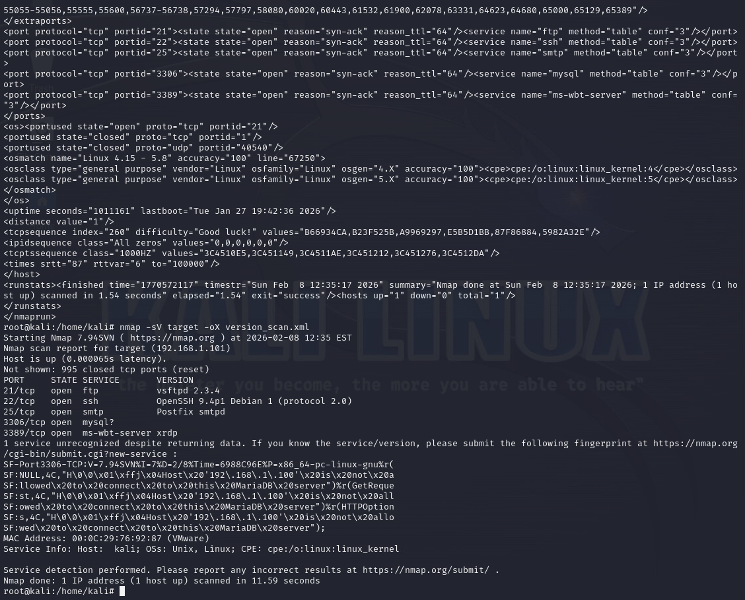
Service Version Detection

Applied Nmap
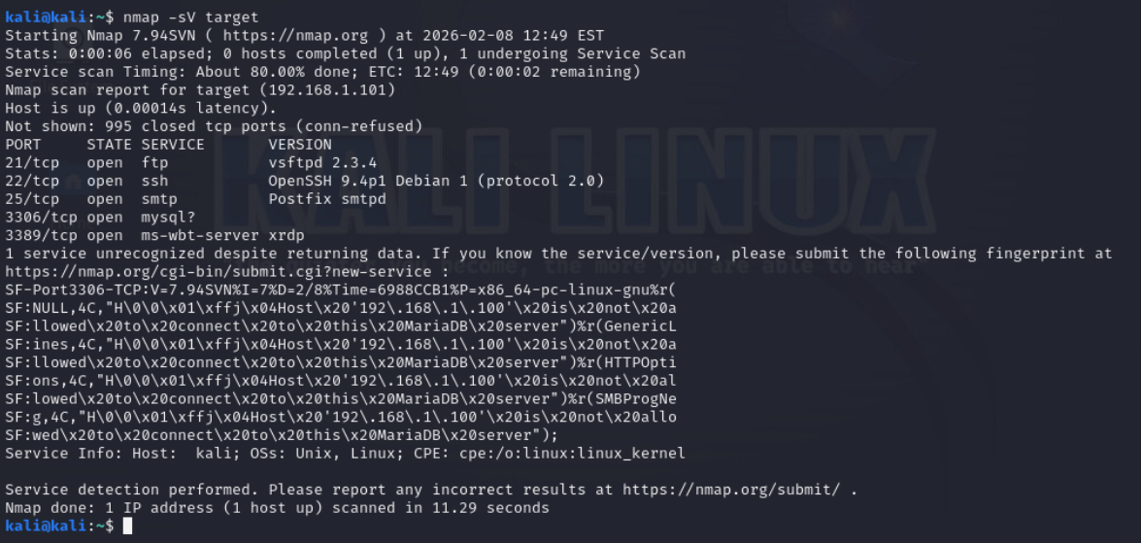
Scanning the Target
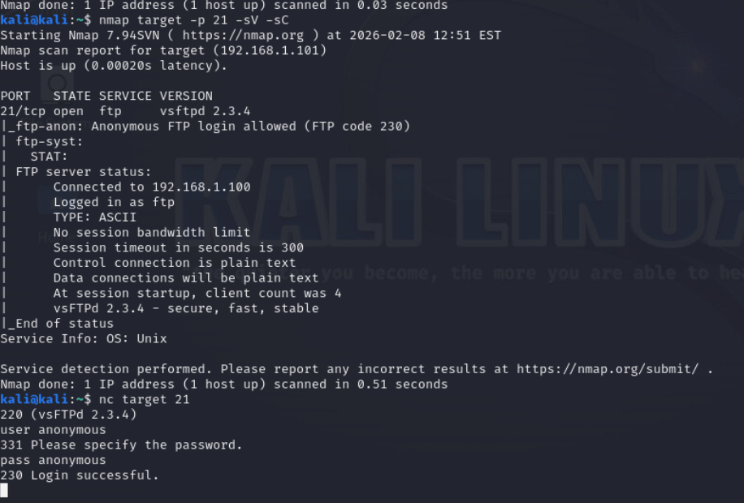
Leveraging Open Ports for Social Engineering and Credential Attacks
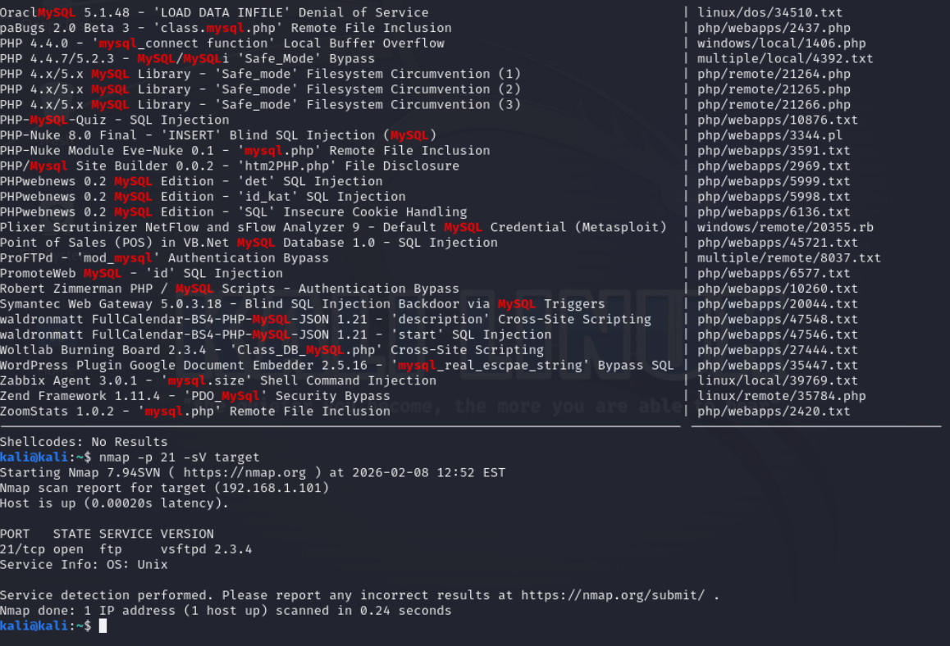
Leveraging Frameworks and Databases for Exploit Discovery and Testing

Basic Scripting
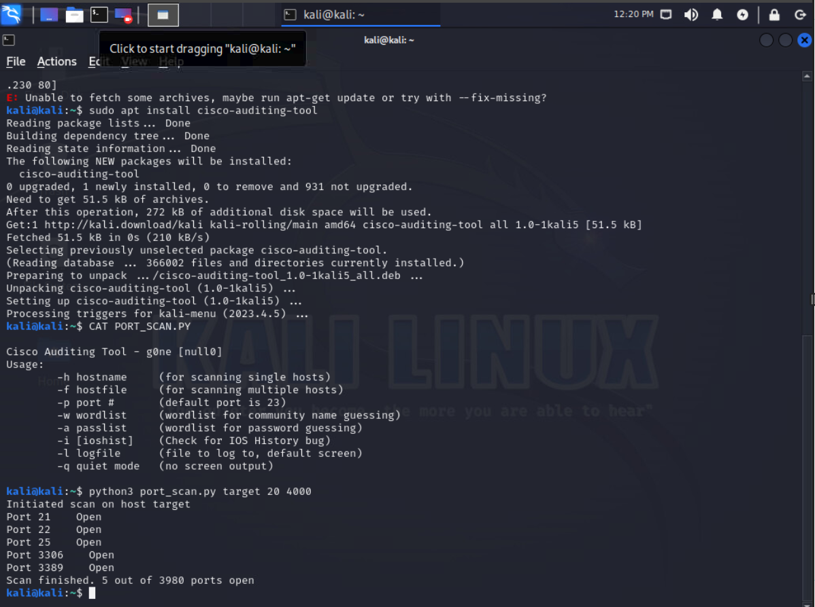
Utilizing python for scaning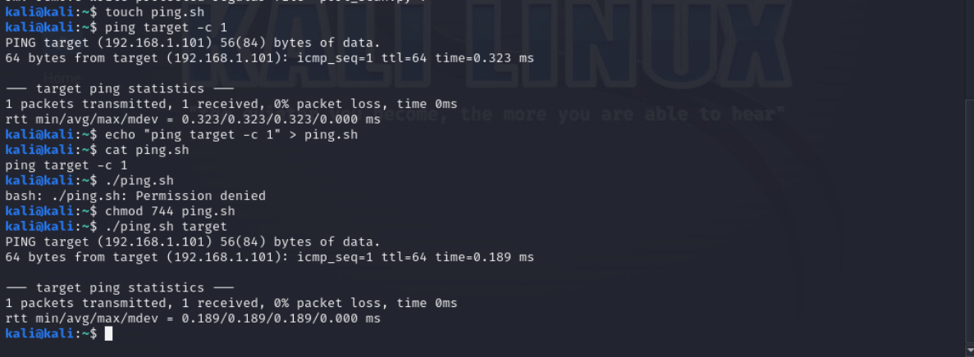
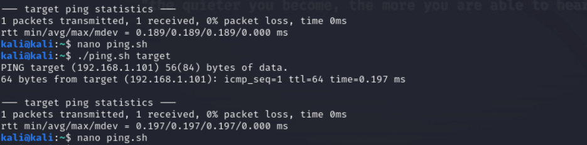
Enhancing a Ping Script with Shebang and Parameters

Lab Completion
